**Leader Overview**

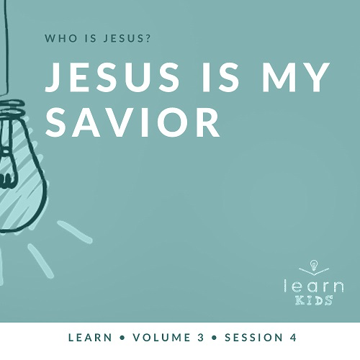

**Volume Overview**

**Who is Jesus?**

*In the classic book* Mere Christianity*, C. S. Lewis reasoned that those who refuse to believe Jesus’ claim to be God are left with the option of labeling Him as a lunatic or the devil. Jesus asked His closest followers who people thought He was (*[*Matthew 16:13*](https://ref.ly/logosref/Bible.Mt16.13)*). The disciples responded with far-ranging opinions. But then Jesus turned the question on them: “Who do you say I am?” Two thousand years later, there may not be a more important question for any of us to answer*.

**Session Overview**

**Jesus Is My Savior**

*At the end of John’s Gospel, Jesus met with His disciples and restored Peter. This story is a reminder that Jesus is our Savior. He is willing to forgive us even when we have disappointed or denied Him. If we believe in Jesus and ask Him to forgive our sins, then we are saved. As Christians, we should desire to share this good news of who Jesus is with everyone*.

**Bible Lesson**

Jesus Forgives Peter

[John 21:1–19](https://ref.ly/logosref/Bible.Jn21.1-19)

**Faith Fact**

Jesus forgives.

**Faith Verse**

[John 3:16](https://ref.ly/logosref/Bible.Jn3.16) (NLT)

“For this is how God loved the world: He gave his one and only Son, so that everyone who believes in him will not perish but have eternal life.”

**Preparing for the Session**

**Leader Preparation Time: 20–25 Minutes**

|  |
| --- |
| ***You Will Need***  ***Large Group***  *• Bible*  *• Worship songs (Song suggestions: “Real Love” by Hillsong Young and Free; “This Is Amazing Grace” by Phil Wickham; “Good Father” by Chris Tomlin)*  *• For groups not using a phone or tablet only, add:*  *• Projector or TV*  *• Laptop*  *•* ***Faith Fact Slide***  *•* ***Faith Verse Video*** *or* ***Slide***  *•* ***Bible Lesson Video***  *•* ***Teaching Point Slides 1–3***  *• Balloons, one per kid (or fewer if you have a large group)*  *• Optional: Permanent marker*  *• Cupcake birthday candle*  *• Birthday hat*  *• Small, wrapped present or gift bag*  *• Chair*  *• Optional: Birthday balloon on a string*  *• Ball for a team sport*  *• Sports whistle*  *• Backpack*  *• Rocks*  ***Small Group***  *• Sheet or blanket*  *• Table tennis ball*  *• Bibles for kids in your group to share*  *•* ***Small Group Activity Page****, one per kid*  *• Pencils, one per kid*  *To access session content and videos from a computer, visit:* [*BibleEngagementProject.com/downloads*](https://bibleengagementproject.com/Downloads) |
| ***Getting Ready***  ***Large Group***  *• Download videos and slides if needed.*  *• Select worship song(s) and have them ready to play.*  *• Read the Bible Lesson Scripture to prepare for teaching time.*  *• Inflate and tie off balloons.*  *• Optional: Draw a simple fish on each balloon.*  ***Small Group***  *• Print copies of the* ***Small Group Activity Page****, one per kid.*  *First time leading* Learn *for Kids? Check out the* [Facilitator Guide](https://0b769b0ed3569ef9d18b-f88d8272f61086866d50d048b43ef630.ssl.cf2.rackcdn.com/sites/biblengagementproject/Listen_Facilitator_Guide.pdf). |

**Large Group**

**30 Minutes**

*See what’s needed at the beginning of the session.*

**Introduction**

I’m so glad you’re here to discover more about Jesus with me. Jesus is very special. He showed God’s love to the world in a way that had never been seen before. Today, we’ll see how Jesus forgave His friend Peter who had betrayed Him. Jesus does the same for you and me.

**Faith Fact**

That’s why our Faith Fact today is **Jesus forgives.**

• *Show the* ***Faith Fact Slide***.



We all need forgiveness sometimes. When you need forgiveness, show me what your face might look like. *(Group response)* Hold that look. Let’s say our Faith Fact. **Jesus forgives.** Now show me what your face looks like after Jesus forgives you. *(Group response)* Let’s shout our Faith Fact. **Jesus forgives.** Great job!

**Game**

**Balloon Pop**

|  |
| --- |
| ***You Will Need***  *• Balloons, one per kid (or fewer if you have a large group)*  *• Optional: Permanent marker*  ***Getting Ready***  *• Inflate and tie off balloons.*  *• Optional: Draw a simple fish on each balloon.* |

In our Bible story today, some of the disciples are fishing. Let’s play a game where we’re trying to catch fish like they were trying to do.

• *Hand out the inflated balloons*.

Let’s pretend that these balloons are our fish. When I say, “Go,” throw your balloon up in the air and tap it away from you. When they land, it’s time to go fishing. To complete the fishing process, grab a balloon and sit on it to pop it. The person who pops the first balloon wins. Wait! There’s a catch. If you go fishing in a boat, you have to stay in the boat. Right? *(Group response)* During our game, you have to stay in your seat to play. If you move out of your seat to get a “fish,” you’re out.

• *Play the game until the first fish is caught*.

• *Continue playing until all the fish are caught*.

Thanks for playing. Raise your hand if you caught at least one fish. *(Group response)* We’ll find out in our Bible story later that Jesus’ disciples didn’t catch any fish until Jesus helped them out. Now, let’s worship.

**Worship**

Let’s worship God by singing together.

• *Lead the kids in singing one or two praise songs. See suggestions at the beginning of the session*.

**Bible Lesson**

Now, let’s get ready to look at God’s Word. Get out your Bible or pull it up on an app so we can read it together. In our story today, we’ll see Jesus forgive one of His closest friends. Before Jesus died, Peter had denied that he even knew Jesus. Not once, not twice, but three times Peter said he didn’t know Jesus.

Everyone, think about your closest friend. What would you do or how would you feel if they betrayed you? *(Allow responses.)* If my best friend did something like Peter did, it might be hard for me to forgive them. Let’s see how Jesus responded to what His friend did. While we listen to this story, let’s think of how this applies to us today. Let’s pray before we begin.

**Prayer**

|  |
| --- |
| Dear God, please help us learn from Your Word today. Show us how we can be more like Jesus and forgive people who hurt us. Amen. |

**Video Intro**

Before we read our Bible story, let’s watch this video and see what Dash is doing.

• *Play* ***Bible Lesson Video***.

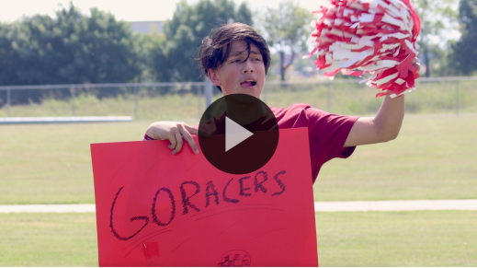

**Bible Story**

**Jesus Forgives Peter**

That was such a fun lead-in to our Bible story today! Earlier, we talked about what you might do if your friend betrayed you. It’s never easy when someone hurts us. What’s something a friend might do that would hurt your feelings? *(Allow responses.)* Do you think that you’d be able to forgive them? *(Group response)*

Forgiveness isn’t easy, especially if we feel like we can’t trust that person anymore. Let’s see what Jesus did when He was in that situation with His friend Peter. Open your Bible to [John 21:1–19](https://ref.ly/logosref/Bible.Jn21.1-19).

• *Read the Bible story aloud to the group*.

• *In order to keep Large Group time moving along, we don’t recommend having the kids read*.

• *Optional: Remind the kids to mark this place with their Bible Bookmark, so they can read it on their own at home*.

**Teaching Time**

|  |
| --- |
| ***You Will Need***  *• Cupcake birthday candle*  *• Birthday hat*  *• Small, wrapped present or gift bag*  *• Chair*  *• Optional: Birthday balloon on a string*  *• Ball for a team sport*  *• Sports whistle*  *• Backpack*  *• Rocks*  *No prep needed for this activity.* |

Can you imagine being Peter in that moment? There’s so much going on here. Peter followed Jesus for about three years. He saw Jesus do miracles. He learned from Jesus and became one of His closest disciples. In the time when Jesus was in trouble, Peter got scared and pretended that he had never met Jesus.

We saw in our story today that Jesus not only forgave Peter, but He also still wanted Peter to be a part of helping to share His message of God’s love with others. Let’s see what we can learn from that.

**1. Jesus is present in our daily life.**

• *Show the* ***Teaching Point 1 Slide***.

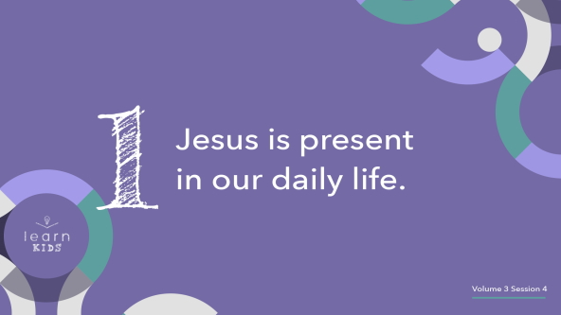

Isn’t it crazy that when Jesus called to His disciples on the boat, they didn’t recognize Him right away? *(Group response)* They might not have recognized Him immediately, but Jesus was still nearby. He was present in their daily life. Once they realized He was there, they went to see Him.

• *Choose a volunteer to sit on a chair next to you*.

Imagine if people treated you like it was your birthday every day. How many of you would like that? *(Group response)* Of course, you would. That would be amazing! What kind of cool stuff happens on your birthday? *(Allow responses.)*

• *As the kids name birthday items that you have, hand them to the volunteer*.

On our birthday, we might get a special meal, some gifts, and maybe even a party. It’s all a lot of fun. Now, what’s the point of someone giving you a gift or making a cake for you? *(Allow responses.)*

People do these things on your birthday to show that they care about you and love you. Birthdays only happen once a year. Do people only care about us once a year? No way! We’re loved by our friends and family all year long. Their love is always present whether we see and feel it or not; however, we choose one special day to celebrate it. In the same way, Jesus is always present with us whether we realize it or not.

**2. We must choose to believe in Jesus and obey Him.**

• *Show the* ***Teaching Point 2 Slide***.

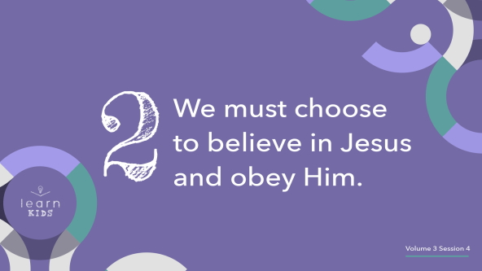

We know Jesus is always with us, but He will never force us to do anything we don’t want to do. We can choose whether or not we want to follow Him just like Peter. The truth is that if we want to follow Him and have eternal life, then we need to have faith that what He says is true. We need to choose to obey Him and follow His directions.

It’s kind of like being on a sports team. Does anyone here play sports? *(Group response)* What sports do you play? *(Allow responses.)* Those are really cool!

• *Hold up the sports ball*.

There are many people on a sports team. They might all have a different idea for the best way to score points or to win against the other team. How do they decide on what plan they will follow? *(Allow responses.)*

You’re right! They follow the coach. *(Blow the whistle.)* The coach isn’t on the court or field with the team, but they’re watching and giving directions to the team about what the players need to do to win. The coach knows what’s best and needs each player on the team to trust him or her and follow their directions.

Our faith is a lot like this. We need to trust that Jesus knows what’s best. We need to follow His directions. Jesus wants us to win the game of life by accepting the gift of eternal life that He is offering us.

**3. Jesus always forgives those who love Him.**

• *Show the* ***Teaching Point 3 Slide***.

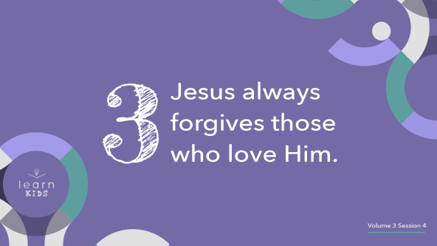

Sometimes, we might think that if we decide to follow Jesus, then we have to be perfect at obeying Him. While Jesus doesn’t want us to mess up, He knows that we will mess up like Peter did. Jesus will forgive us anytime we ask for it.

Once when Jesus was teaching, Peter asked Him what the maximum number of times to forgive someone should be. Peter asked if seven times was enough, but Jesus answered with a different number. Any guess what that number was? *(Allow responses.)* Jesus told Peter, “Not seven times, but seventy times seven.” Seventy times seven is 490 times. Have you forgiven anyone that many times? *(Group response)* I haven’t.

• *Choose a volunteer and have the kid put on the backpack*

• *Read the following story as you add rocks to the backpack or tell your own story*.

*(to volunteer)* How does the backpack feel? It’s not too heavy is it? *(Allow response.)* Probably feels pretty light.

Imagine you were walking into your school one day and a group of kids walked by and began to call you mean names. *(Place a rock in the backpack.)* The words others say to us sometimes can be very hurtful. As you arrive at your classroom, another kid who is older and a lot taller comes up to you. In front of everyone, that kid tells you they don’t like your shoes. *(Place a rock in the backpack.)*

Then how would you feel if you had been saving up your money to buy something really special. You were going shopping right after school, but the money was taken from by someone you thought was a friend. *(Place a rock in the backpack.)*

*(to volunteer)* Is the backpack feeling heavier? *(Allow response.)* Let’s say you had been invited to a birthday party on Saturday that you were really excited about going to. But on Friday, you were told that you were no longer invited. *(Add more than one rock to the backpack.)* Sometimes, other people can do and say things that hurt our feelings.

*(To volunteer)* How does the backpack feel now? *(Allow response.)* When people hurt us, it can be just like this backpack. It gets heavier and heavier, which makes it harder to forgive them.

Jesus wasn’t telling us to keep track of someone’s mistakes up to 490. He wasn’t saying that we don’t have to forgive when we’ve been hurt 491 times. Jesus was saying to not keep track of them at all because that’s what He does for us.

• *Remove the backpack*.

• *Volunteer can return to their seat*.

Jesus takes what we’ve done and forgives us. He helps us to forgive others too. He always forgives those who love Him when we ask Him to.

**Prayer and Response**

*Consider playing a worship song softly in the background while kids pray*.

Jesus forgives. Just like with Peter, Jesus forgives the sin in our life and heart. Because He has forgiven us, we can forgive others. I want us to spend some time praying about two things. First, if you need to ask Jesus to forgive you for something wrong that you’ve done, ask Him. He will forgive you.

Second, ask Jesus to show you if there is someone that you need to forgive. When we forgive others, we’re saying that we won’t hold what they’ve done wrong against them anymore. We can be like Jesus when we forgive others. Let’s seek Him on our own quietly. Then, I’ll close in prayer in a few minutes.

• *Be sensitive to the Holy Spirit’s leading. You may have kids who are ready to invite Jesus into their life as their Savior*.

**Prayer**

• *Optional: Have the kids repeat phrases of the prayer after you*.

|  |
| --- |
| Dear Jesus, thank You for being willing to forgive us for how we’ve hurt You. Thank You for being our Savior. It’s not easy to forgive, so help us to forgive those who have hurt us, too. Amen. |

**Faith Verse**

I really hope that you heard from God today. If you didn’t, don’t worry. God speaks to us in many ways and at different times. Being able to hear His voice is something we practice. Our Faith Verse reminds us that God loved us so much that He sent Jesus to give us eternal life.

• *Play* ***Faith Verse Video***.

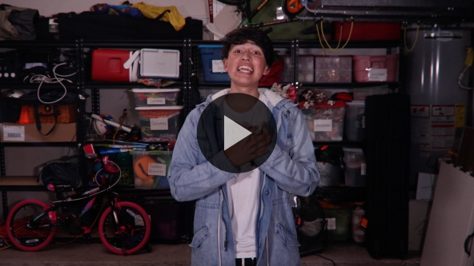

[John 3:16](https://ref.ly/logosref/Bible.Jn3.16) (NLT)

“For this is how God loved the world: He gave his one and only Son, so that everyone who believes in him will not perish but have eternal life.”

We can have eternal life because Jesus forgave us. We can be thankful for that forgiveness and share it with others.

**Faith Fact**

Before we go to our small groups, let’s review our Faith Fact.

• *Show the* ***Faith Fact Slide***.



Say it with me. **Jesus forgives.** Hey, kids! It’s been great learning with you today.

• *Dismiss kids to Small Group time or to go home if your group time ends here*.

**Small Group**

**30 Minutes**

*This section can be done in conjunction with the large group or on its own if you do small groups with your kids. During Small Group time, the goal is to connect the kids with the Word of God and to each other. All activities are led by the small group leader.*

**Group Connection**

**Sheet Table Tennis**

|  |
| --- |
| ***You Will Need***  *• Sheet or blanket*  *• Table tennis ball*  *No prep needed for this activity.* |

When it comes to forgiveness, there are always two sides to it. If we think about Jesus and Peter, first Peter messed up, and then Jesus forgave Peter. Finally, Peter accepted Jesus’ forgiveness and went on to tell thousands of people about Jesus’ love for them.

Let’s play a game with sides. We’ll divide the group into two teams. One team will stand and hold one side of the sheet, and one team will stand and hold the other side.

• *Pause while kids get into teams and hold the sheet flat*.

Now, I’m going to put a table tennis ball in the middle of the sheet. Your team’s goal is to raise and lower the sheet and try to get the ball to fall off on the other team’s side. When you score, shout out the Faith Fact: **Jesus forgives.** Let’s play.

• *Optional: Keep score*.

When we do forgiveness the right way, it should fall away just like that ball did. That’s what forgiveness from Jesus is like. He won’t keep reminding us about what we did that was wrong.

**Learn about It**

|  |
| --- |
| ***You Will Need***  *• Bibles for kids in your group to share*  *No prep needed for this activity.* |

**Scripture Search:** [**Acts 4:11–12**](https://ref.ly/logosref/Bible.Ac4.11-12)**;** [**Romans 5:6–9**](https://ref.ly/logosref/Bible.Ro5.6-9)**;** [**Ephesians 2:8–9**](https://ref.ly/logosref/Bible.Eph2.8-9)**;** [**1 Timothy 2:3–6**](https://ref.ly/logosref/Bible.1Ti2.3-6)

Now, let’s dig deeper into God’s Word and see what else He has to say to us. As we find and read each of these verses, let’s consider: What does this Scripture mean for our life today?

• *Give each kid a Bible and search for one or more of the Scriptures as a group together (as time allows). When everyone has found the Scripture, have one of the kids read it. Then, answer the questions about it*.

• *Pair kids who need additional help with older kids or start simple and look up the session’s Bible story Scripture:* [*John 21:1–19*](https://ref.ly/logosref/Bible.Jn21.1-19)*. Kids will get better finding Scriptures the more they practice*.

• *Optional: Make this a competition to see who can find the Scripture first*.

**Bible Reading Tip**

Did you know that there are many different kinds of books in the Bible? There are sixty-six books. Some of them are letters, some have poems, some are historic accounts, and others have prophecies. It can help us when we read God’s Word to know the differences in what we’re reading. If you ever need help, you can ask your parent or a leader or look online. Some Bibles even have information about this at the beginning of each book.

**Challenge**

This week’s challenge is a little unusual. I want you to look for rocks. Find rocks of different shapes and sizes. Choose a few to keep and put in a place that you’ll see them regularly. They represent different mistakes that you’ve made and that other people have made against you. When you see those rocks, I want you to remember how much Jesus loves you. He died so that you can be forgiven of all those mistakes. I want you to pray and thank Him for forgiving you and then ask Him to help you forgive others.

**Faith Fact**

That reminds me of our Faith Fact. Say it with me. **Jesus forgives.** Now, whisper it as quietly as you can. **Jesus forgives.** Let’s say it in a low voice. **Jesus forgives.**

**Group Discussion**

*Feel free to use all or just a few questions as a jumping-off place for good discussion. Questions marked with * are designed for more conversation. Adjust the questions based on the age or maturity of your group. Typically, older kids will be able to dive a little deeper than younger ones*.

**Questions**

• *If small group activities are not immediately following large group time, you may want to read the Bible story passage before this discussion*.

At the beginning of the story, what had some of the disciples decided to do?

What happened when the disciples couldn’t catch any fish?

What did Jesus do with the disciples after they came to shore?

What question did Jesus ask Peter?

* Why do you think Jesus asked Peter this question?

Did Jesus forgive Peter?

* How is Jesus present in our daily life?

* What can we do to believe in Jesus and obey Him?

* How does it feel to know that Jesus will always forgive you when you ask?

* What’s the most difficult thing for you when it comes to forgiving others?

**Prayer Requests**

*Finish group discussion by sharing prayer requests and praise reports. Keep track of your small group’s prayer requests and review them each time you meet*.

**Prayer**

*Have kids pray for each other’s prayer requests*.

**Faith Verse Review**

Our Faith Verse is [John 3:16](https://ref.ly/logosref/Bible.Jn3.16). It tells us that we know God loved us because He sent Jesus to give each of us eternal life. Anyone who believes in Jesus can have it. Let’s watch the Faith Verse video and do the actions together.

• *Show* ***Faith Verse Video***.



[John 3:16](https://ref.ly/logosref/Bible.Jn3.16) (NLT)

“For this is how God loved the world: He gave his one and only Son, so that everyone who believes in him will not perish but have eternal life.”

**Faith Verse Fun**

**Gotcha!**

This verse is one of the most important verses in the whole Bible, so let’s try to keep it in our head and in our heart with a game. I’m will say the verse but will leave out a word or phrase. If you catch me, say, “Gotcha!” If you’re right, you get to lead the next round. Let’s play.

• *Say the verse to the kids, strategically messing up one word, phrase, idea each time*.

**Activity Page**

**He Forgives, I Forgive**

|  |
| --- |
| ***You Will Need***  *•* ***Small Group Activity Page****, one per kid*  *• Pencils, one per kid*  ***Getting Ready***  *• Print copies of the* ***Small Group Activity Page****, one per kid.* |

Jesus forgives, and that simple fact changes our world. When Jesus is our Savior, we will live with Him forever one day. For now, we can share the hope of eternal life with others around us. We can grow in our trust of who Jesus is and what He’s done for us because of His love.

No matter how hard we try, we’ll never be perfect. We’ll still need forgiveness sometimes. People will still hurt us, too.

• *Give each kid a copy of the* ***Small Group Activity Page*** *and a pencil*.

We need to ask God to show us what we need forgiveness for and who we need to forgive. On the left side, draw or write about something Jesus has forgiven you for. Then on the right side, draw or write about something you need to forgive someone else for.

• *Optional*: *If you just did the large group Response Time, you may want to reference what God showed them about forgiveness. They might choose to write or draw those things on their page*.

• *This is a great opportunity for you to find out more about your kids and what they’re facing*.

**Dismissal**

Thanks for coming today! We learned a lot about Jesus our Savior today. His willingness to forgive us when we ask is something we need to be very thankful for. Let’s close in prayer.

**Prayer**

|  |
| --- |
| Dear God, thank You so much for Your forgiveness. We know that You are perfect and that everything You told us in Your Word is true. Help us to follow You every day. Amen. |

**Faith Fact Recap**

• *Show the* ***Faith Fact Slide***.



One important thing I want you to remember from today is our Faith Fact. Let’s say it together one more time. **Jesus forgives.** I’m glad you came today. I can’t wait to see you next time.

• *Send home the* ***Small Group Activity Page***.

• *Remind parents that there are* ***Family Devotions*** *available on the app to do with their kid*.

• *Tell everyone the date and time for the next session*.

.